

**Project Topic : Smart Traffic Management System**

**Submitted By:**

**Siristi Rani Paul**

**ID: 02**

**Batch No :53**

**Department of Law**

**University of Barishal**

**Submitted To:**

**Md. Mahbub E Noor**

**Lecturer**

**Department of CSE**

**University of Barishal**

**Date of Submission :14 December,2024**

Smart Traffic Management System: A Comprehensive Overview

# Introduction

Traffic congestion is a pervasive urban issue that significantly impacts economic productivity, environmental quality, and quality of life. Traditional traffic management systems often struggle to adapt to dynamic traffic conditions, leading to inefficient traffic flow and increased travel times. To address these challenges, Smart Traffic Management Systems (STMS) have emerged as a promising solution. By leveraging advanced technologies, STMS aim to optimize traffic flow, reduce congestion, and enhance overall urban mobility.

# Components of a Smart Traffic Management System

A typical STMS comprises several interconnected components:

## Sensor Network:

* + **Vehicle Detection Sensors:** These sensors, such as inductive loop detectors, radar sensors, and video cameras, detect the presence, speed, and direction of vehicles.
  + **Environmental Sensors:** These sensors monitor weather conditions, air quality, and other environmental factors that can impact traffic flow.

## Communication Network:

* + **Wireless Communication:** This network enables seamless data transmission between sensors, traffic controllers, and the central control center using technologies like Wi-Fi, cellular networks, and dedicated wireless networks.

## Central Control Center:

* + **Data Processing and Analysis:** This center collects, processes, and analyzes data from various sensors to identify traffic patterns, congestion points, and potential issues.
  + **Traffic Management Strategies:** The center implements real-time traffic management strategies, such as adaptive traffic signal control, dynamic lane allocation, and traffic rerouting.
  + **Incident Management:** The center responds to traffic incidents like accidents or road closures by adjusting traffic signals, rerouting traffic, and providing real-time information to drivers.

1. **Vehicle-to-Infrastructure (V2I) Communication:**
   * **Real-time Traffic Information:** V2I communication enables vehicles to receive real-time information about traffic conditions, congestion, and alternative routes through in-vehicle displays or mobile apps.
   * **Cooperative Vehicle Control:** V2I communication allows vehicles to coordinate with traffic infrastructure to improve traffic flow and safety.

# Smart Traffic Management System: A Table Overview

|  |  |
| --- | --- |
| Component | Description |
| Sensor Network | Detects and collects real-time traffic data, including vehicle presence, speed, and direction. |
| Communication Network | Transmits data between sensors, traffic controllers, and the central control center. |
| Central Control Center | Processes and analyzes traffic data to make informed decisions and implement traffic management strategies. |
| Traffic Signal Controllers | Adjusts traffic signal timings based on real-time traffic conditions. |
| Vehicle-to-Infrastructure (V2I) Communication | Enables vehicles to communicate with infrastructure to receive real-time traffic information and warnings. |

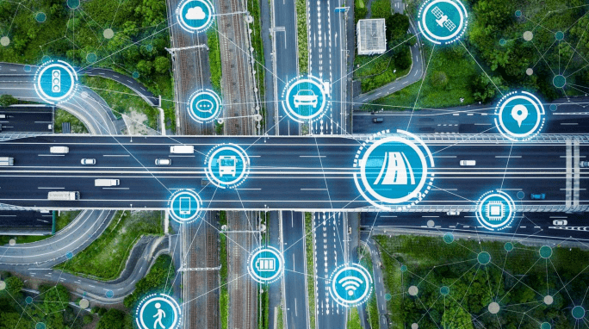

# Benefits of Smart Traffic Management Systems

The implementation of STMS offers numerous benefits:

* **Reduced Congestion:** By optimizing traffic flow through adaptive signal control, dynamic lane allocation, and intelligent routing, STMS can significantly reduce congestion.
* **Improved Air Quality:** STMS can help reduce vehicle emissions and improve air quality by minimizing idling time and traffic congestion.
* **Enhanced Road Safety:** By detecting and responding to accidents and other hazardous situations promptly, STMS can reduce the risk of accidents and injuries.
* **Efficient Public Transportation:** STMS can prioritize public transportation vehicles, improving their reliability and efficiency.
* **Sustainable Urban Development:** By encouraging the use of public transportation and reducing reliance on private vehicles, STMS can contribute to sustainable urban development.

# Challenges and Future Directions

While STMS offer significant potential, several challenges need to be addressed:

* **Data Privacy and Security:** Protecting the privacy and security of personal data collected by sensors and communication systems is crucial.
* **Interoperability:** Developing standardized protocols and data formats is essential to ensure seamless integration of different components and systems.
* **Public Acceptance:** Educating the public about the benefits of STMS and addressing concerns related to privacy and surveillance is necessary.
* **Emerging Technologies:** Exploring the potential of emerging technologies like artificial intelligence, machine learning, and autonomous vehicles can further enhance STMS capabilities.

Future directions for STMS include:

* **Advanced Sensor Technologies:** Developing more accurate and reliable sensors to collect high-quality data.
* **Artificial Intelligence and Machine Learning:** Utilizing AI and ML algorithms to analyze complex traffic patterns and make intelligent decisions.
* **V2X Communication:** Expanding V2X communication to enable vehicles to communicate with each other, infrastructure, and pedestrians.
* **Autonomous Vehicles:** Integrating autonomous vehicles into the transportation system to optimize traffic flow and reduce accidents.

A smart traffic management system (STMS) is a network of sensors, cameras, and data analytics tools that work together to monitor, control, and manage traffic flow in real time. STMSs help to:

* **Reduce congestion**

STMSs can help to reduce congestion by analyzing traffic data to optimize traffic patterns and reroute vehicles.

* **Improve road safety**

STMSs can help to improve road safety by providing traffic controllers with the information they need to make informed decisions.

* **Improve emergency response times**

STMSs can help to improve emergency response times by detecting emergency vehicles and adjusting traffic signals to give them priority access.

# Advantages of a Smart Traffic Management System

Cleaner, greener, safer, and more accessible roads are a few benefits of implementing IoT and intelligent technology.

It helps with the following:

* Reducing traffic jams and accidents on the streets
* Ensuring immediate clearance for emergency vehicles
* Facilitating safer and shorter commute times
* Reducing congestion & energy consumption at intersections
* Offering significant productivity benefits with real-time monitoring of crucial infrastructures
* Reducing operating costs with efficient traffic management processes
* Ensuring compliance with the regulations for reducing the carbon footprint
* Saving billions of gallons of fuel wasted every year
* Accurate tracking & quick recovery of lost and stolen vehicles.

# Implementation of a Smart Traffic Management System – Key Elements

Whether municipalities want to improve their traffic management approach, expand public services, or upgrade existing infrastructure – it all starts with a smart city solution!

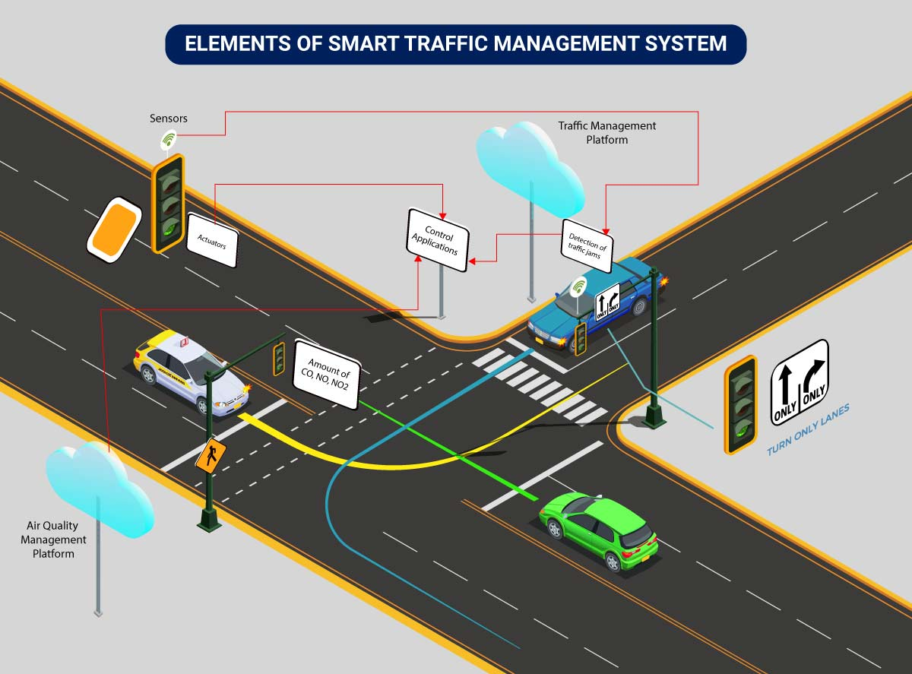

Here’s an implementation plan for building a scalable traffic control system using IoT capabilities:

A basic architecture that serves as a launchpad for feature enhancements and service upgrades will integrate the following components:

* **Sensors**for collecting data and sending it to a centralized cloud platform
* **Actuators**for physical devices to make necessary adjustments like – restricting the water supply in pipelines with leakages or dimming & brightening streetlights based on weather conditions.
* **Field gateways**to collect & compress data before moving it to a cloud platform.
* **Cloud gateways**enable secure data transfer between field gateways & the cloud storage of the traffic management system
* **A data lake**to store the raw, unstructured information before it is cleansed, processed, transformed & moved to a data warehouse for extracting actionable insights
* **Data warehouse**stores contextual information about connected objects and devices installed with sensors and actuators.
* **Data analytics**for analyzing the data from streetlight sensors on a centralized dashboard to adjust the intensity of lights
* **ML algorithms**to analyze traffic patterns & trends from historical data – stored in the data warehouse. The identified trends are then used to build predictive models for control apps. These apps modify the average vehicle speed to avoid congestion.
* **Rules**to enable actuators to automate the functioning & control of smart city objects and devices. These rules are manually defined to tell actuators what needs to be done to solve a specific problem.
* **User applications** that allow citizens to receive instant notifications in case of traffic jams and congested routes. Desktop user apps for control rooms send commands to actuators for altering traffic signals. It helps to relieve congestion and optimize routes.
* **Cross-solution integrations** with traffic lights or streetlight management systems. Control apps apply ML models or predefined rules to prompt appropriate output action if the air quality is poor.

Cities of all sizes can leverage this approach. Depending on the budgetary and procurement constraints, they can start small. It would be with solutions like – a littering offense ticketing system or a smart parking app. Later they can expand the range of services.

# Case Studies of Successful STMS Implementations

Several cities around the world have successfully implemented STMS to improve traffic flow and reduce congestion. Some notable examples include:

* **Singapore:** Singapore has a world-class STMS that uses advanced technologies to manage traffic efficiently. The system incorporates a range of sensors, cameras, and communication technologies to collect and analyze real-time traffic data.
* **London:** London's Congestion Charge Zone and Low Emission Zone have been successful in reducing traffic congestion and improving air quality. These measures, combined with advanced traffic management systems, have helped to alleviate traffic problems in the city.
* **Portland, Oregon:** Portland has implemented a comprehensive STMS that includes adaptive traffic signal control, real-time traffic information, and incident management. The system has helped to reduce congestion, improve air quality, and enhance public transportation.

# Conclusion

Smart Traffic Management Systems offer a promising solution to address the challenges of urban traffic congestion. By leveraging advanced technologies and data-driven insights, STMS can create more efficient, sustainable, and livable cities. As technology continues to evolve, we can expect to see even more innovative and sophisticated STMS that will further enhance urban mobility.